Welcome to BBC Classifieds
October 2023

Page 1 of 4
Computer Sales, Repairs, Upgrade
Red Mountain Laptops
Windows based laptops repair, upgrades or refurbished laptop sales.
Scott Hodges: (919) 260-5280;
Website: redmountainlaptops.com;
email: RedMountainLaptops@gmail.com

Childcare
Evening/weekend child care available
Becky Sheuneman: (919) 627-4657

Construction/Remodeling
Jack Williams Construction
Remodeling, new construction, punch lists.
Jack Williams: (919) 259-2405;
email: jackman4him@gmail.com

April Glenning/Randy Wagner Co-Editors
(919) 471-3181/info@BahamaBaptistChurch.org

Cutlery Sales
Bonnie Capps is now partnering with Rada Cutlery to provide you with the highest quality products at great prices. You can buy kitchen knives, cooking utensils, cutlery gift sets plus so much more. Ask me for a catalog or go online to www.radacutlery.com and select shop then email, text, or tell me the item numbers you would like to purchase. I will reply with your purchase total, payment options and delivery details.
Bonnie Capps: (919) 384-5625
Email: bonniecapps59@yahoo.com

Flower Arrangements
Wild Aster Farm
Dried flower arrangements.
Melissa English: (919) 810-2401;
website: wildasterfarm.com;
email: Info@wildasterfarm.com

Page 2 of 4
Furniture/Woodworking
Holdfast Concepts & Design
Custom furniture, build, design, and rehab
Johnnathan Williams: (918) 619-3940;
email: holdfastcompany@gmail.com

Health/Wellness
Wild Aster Farm
Dried or fresh medicinal & culinary herbs, seedlings, herbal products, dried flowers(bulk).
Melissa English: (919) 810-2401;
website: wildasterfarm.com;
email: Info@wildasterfarm.com

Home Maintenance
Jack Williams Construction
Plumbing, electrical, home maintenance.
Jack Williams: (919) 259-2405;
email: jackman4him@gmail.com

Knife Making
Holdfast Concepts & Design
Knife making, woodworking and metal fabrication.
Johnnathan Williams: (918) 619-3940;
email: holdfastcompany@gmail.com

Lawn and landscape
CAROLINA SCAPES, LLC LANDSCAPING SERVICES
Lawn maintenance, irrigation work, landscape, lighting, drainage work, patios, outdoor kitchens, firepits, all hardscape needs, landscape design.
Cody Johnson: (919) 698-9769
Rick Johnson: (919) 730-0501

Lawn Mowers/Equipment/Small Engine Services
Ellis Mowers
Quality mowers and other lawn equipment and
small engine repair at affordable prices.
Casey Ellis: (919) 323-1203;
Website: ellismowers.com;
email: ellis@ellismowers.com

Miscellaneous
Housekeeping, Elder Companion, Errands, and Virtual Personal Assistant
Becky Sheuneman: (919) 627-4657

Notary
Please give at least a workday’s notice to assure the seal has been brought home from work.
Teri Harris: (919) 949-2060

Page 3 of 4
Pest Control
House Exterminators
Pest control, termites, mosquitos. We will make your home bug free.
Ricky Duke: (919) 906-9937;
Website: HouseExterminators.com;
email: HouseExterminators@gmail.com

Sewing & Seamstress work
Garment creation, mending, alterations, and quilting. Becky Sheuneman: (919) 627-4657

Items For Sale
Quality Cotton Hang Towels-Use in your kitchen, bathroom, or even baby’s changing table. Thick 100% Cotton Full size (16” x 28”) hand towels folded over and crocheted to hang from a knob, towel ring, rod, or door handle. White with red or blue accent. Makes a thoughtful gift! $5.00 each or 2 for $9.
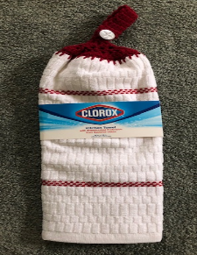
Decorate your kitchen for Fall and Halloween (examples pictured) with full size kitchen towels folded over and crocheted to hang from a cabinet knob or an appliance handle. Makes a charming hostess gift! $4.00 each or 2 for $7.
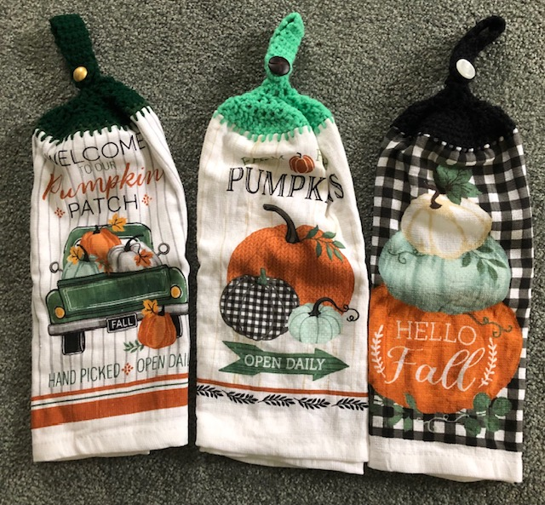
Randy Wagner: (614) 581-3054
email: sunrands@gmail.com

Small trailer- 4’ x 8’. Great for yard work! Best reasonable offer.
Woody Kelly: (919) 740-7496
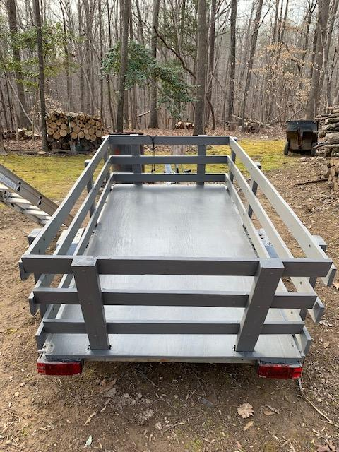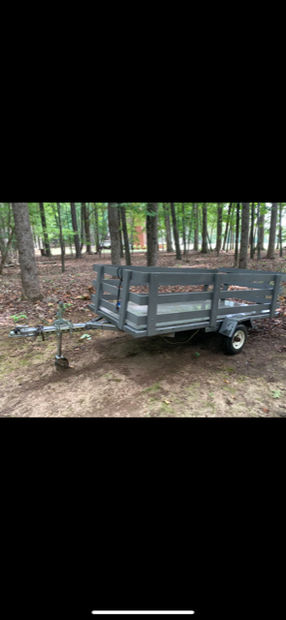

Page 4 of 4

Services Needed

Electric Motor Repair: Repair of small refrigerator motor needed. Contact Don Wagner (614) 581-3072

Hunting spot: If you have land accessible to hunting please contact Darin Dowdy (304) 646-3419

Wood stove and prefabricated duravent chimney installation: Single story, 4/12 pitch.
Contact Tabitha (828) 206-4475

Lost & Found on BBC Property
Lost and Found will be emptied on October 15th. Take a look in the gray tote outside the kitchen area and claim your items.

